ABSTRACT
The medium of cinema often serves as a powerful mirror and mediator of societal realities, offering a platform to articulate, interpret, and challenge deeply rooted social issues. In cTamil cinema directors like Mari Selvaraj, Pa. Ranjith, and Vetri Maaran have effectively utilized their art to act as a voice for the oppressed, shedding light on the harsh realities of caste based discrimination and violence. However, this progressive wave coexists with films that perpetuate prejudice and misinformation, contributing to the very oppression they purport to depict.This paper critically analyzes the film Kavundampalayam (2024), directed by Ranjith, a work that drew immediate and significant condemnation from the Dalit community upon its theatrical release. The central argument of this study is that Kavundampalayam (2024) deliberately employs false narratives and skewed representations to create a negative and misleading public image of the Dalit people and their struggles.This research employs a qualitative methodology to dissect the film's misrepresentations. Using Hall S Theory of Representation as the primary analytical framework, the study examines how the cinematic signifiers in Kavundampalayam (2024) construct a damaging "othering" of the community. Data for this analysis was gathered through observations of the film text, focused group interviews, and one to one interviews with community members. Furthermore, autoethnography is utilized for writing to provide an internal, lived experience perspective, given the author’s position as a member of the Dalit community.

KEYWORDS
Dalits, Misrepresentation, Honour killings, Beef, Food culture, Thirumavalavan, Pretended love, Caste Discrimination, Caste violence, Stuart Hall.

INTRODUCTION
Cinema is generally an art form that helps to express real life events with a degree of imagination, presenting them in a way that people can understand. Society faces numerous problems, with caste based events and issues being a very significant and serious one. However, in the current era, directors like Mari Selvaraj, Pa. Ranjith, and Vetri Maaran are using their art forms to be the voice of the oppressed. Conversely, some directors in the Tamil cinema industry are creating movies with the aim of spreading misinformation about the struggles of the oppressed people.
One such film is Kavundampalayam (2024) , directed by Ranjith. At the time of its theatrical release, this film received huge criticism from the Dalit community. The criticism stemmed from the fact that Director Ranjith had presented the film with false information, seemingly with the intention of creating a negative image of the Dalit people.
This research paper discusses this film, analyzing how it creates a skewed image of the Dalit people and examining whether the events shown in the movie actually occur in society. It also argues that beef consumption is a choice, not a culture, and is merely a food that any individual can have and it does not belong to one particular community. Additionally, this study explores how the leader of the Viduthalai Chiruthaigal Katchi’s (VCK) leader Thol. Thirumavalavan is misrepresented in a negative manner. This research paper employs a qualitative research method through content analysis, utilizing Hall S representation theory. Information was collected through observations, focused group interviews, and one to one interviews. Autoethnography is also used for writimg in this study as I’m the part of the dalit community.This research paper is part of my final year for the subject “Research and Documentation Skills” in my undergraduate degree. The reason I chose this particular topic is that I belong to the Dalit community. As a person from this community, I cannot accept the misrepresentation of Dalit struggles and oppression.

LITERATURE REVIEW
Representation of cast(e) in tamil cinema : pride and prejudice (Devaki V, March 2019)
KEYPOINTS
The article "On Castes and Comedians: The Language of Power in Tamil Cinema" highlights how Tamil film, with its developed codes, has long perpetuated these divisions. The trend of celebrating caste narratives, though beginning in the late 1980s, became more prominent in the 1990s, spreading a strong transitional caste pride. Early examples include the 1974 film En Magan, where actor Shivaji Ganesan, a protagonist from the Thevar caste, explicitly and proudly praises his caste group through dialogue. This continued in many of his subsequent films.Most Tamil films have celebrated dominant castes through their plot and the hero/protagonist, who typically belongs to a dominant caste and acts as a guide. Films like Thevar Magan (1992), Chinna Gounder (1992), and Nattamai (1994) became a trend, making films labeling caste titles a source of pride. Thevar caste dominance, for instance, was brought to the fore in Thevar Magan, with signs, weaponry, and discourse emphasizing their martial nature. Similarly, Cheran’s Bharathi Kannamma features a Thevar zamindar who defines a “real” Thevar by their ability to protect and respect women and shows “honorability” toward other castes. The author contends that this practice in Tamil cinema acts as a motivating factor to hasten casteism and ultimately hinders the eradication of caste and discrimination in society.The text notes that while dominant castes were “the center of the stage,” marginalized/Dalit communities were voiceless and unheard. A significant shift, reminiscent of the line “Things fall apart; the centre cannot hold,” is now occurring with Dalit filmmakers beginning to embrace their identity and tell their own stories. Directors like Pa Ranjith (who is a Dalit and Ambedkarite) and Mari Selvaraj have made the subaltern speak. Pa Ranjith’s Kabali challenged the conventional pattern of the hero belonging to and praising a dominant, high caste. Mari Selvaraj’s Pariyerum Perumal is highlighted as an anti-caste masterpiece and an important milestone. With the rise of these new directors, the power dynamic is changing—the marginalized are coming to the center, and it is “time to hear the]th voice of the voiceless.” The text concludes by asking the rhetorical question, “Can the subaltern speak?” implying that this change is finally allowing them to do so.
This research paper helped me to understand the caste pride being expressed through cast in Tamil cinema and how it has set certain narratives about casteism throughout the years. It also explains how things will automatically fall into place after a certain period of time. For a certain period, so-called dominant caste creators played a vital role in setting narratives about casteism and praising and acknowledging their own caste with pride. On the other side, after many struggles, Dalit filmmakers started to raise their voice for the oppressed people. They changed the so called typical practice of praising caste through cast roles. They made art forms a tool for portraying reality and giving a voice to the people who are voiceless or unheard.
As a continuation of Devaki V's research paper, I criticized the film Kavundampalayam (2024) by Director Ranjith in my paper. In that film, he tried to set fake narratives among people and misrepresented Dalits in a wrong way.

RESEARCH APPROACH, METHODOLOGY AND METHODS
The researcher is using qualitative methodology for this research.
“Qualitative research is a methodology used to gain an in depth understanding of human behavior, experiences, opinions, and motivations. It is primarily focused on non numerical data, such as words, images, and observations, to explore the why and how of a phenomenon”.
The reason why the reasearcher chose qualitative research approach is it is suitable for analyse the overall content, dialogue, scenes, shots, etc.,. Of the Kavundampalayam movie to compare them with the real events.
The researcher also uses the content analysis, observation methodology, focused group interview, one to one interviews for methods and autoethnography for writing as the researcher is the part of the dalit community.

REPRESENTATION THEORY AS FRAMEWORK
This study employs a descriptive qualitative approach, utilizing Hall S representation theory. “Representation theory is a critical framework for analyzing how media, including movies, constructs meaning about people, groups, events, and ideas, rather than simply reflecting reality. It is central to understanding the relationship between media, power, and ideology”. (Hall S, 1997)
Hall S rejects the idea that a movie is simply a “mirror” of reality (the Reflective view) or that its meaning is fixed only by the filmmaker (the Intentional view). Instead, he favors the Constructionist View, arguing that meaning comes from language and systems of signs (like cinematic codes, symbols, and dialogue). Movies use these signs to build a representation that actively shapes and explains the world for the audience.
Hall S model of communication includes encoding and decoding. Filmmakers encode meaning into messages, which viewers then decode to create understanding. Encoding is how the creator builds meaning, often influenced by their own views, biases, and beliefs. Decoding is how an audience reads the message, influenced by their own experiences, culture, and knowledge.
Three Ways of audiences reading,
Hall S says audiences can read media messages in three main ways. They are preferred readings, negotiated readings, and oppositional readings.
A dominant reading is when the audience accepts the message exactly as the creator meant it.
A negotiated reading is when the audience partly agrees with the encoded message but changes it to fit their own beliefs or life.
An oppositional reading is when the audience rejects the creator’s message completely, often because of different beliefs, personal knowledge, or cultural background.

DALITS ARE BEING MARGINALIZED (KILLED IN THE NAME OF HONOUR) OR NOT?
In this movie, Director Ranjith portrays Dalits, setting a fake narrative that so called higher caste people are being marginalized and oppresed people are not being marginalised through the dialogue of character Kuzhandhai (acted by Ranjith) at the climax. That dialogue also portrays that honour killings are not murder but rather the care of the parents, because Dalit youngsters are pretending love for money. How dare a murder be called care?
The dialogue is
“Equality… You don’t need caste when you’re in love… You don’t need caste when you go to the Registrar’s office… But when a problem arises, you suddenly take up caste as a weapon… Caste is an old, healed scar… Why do you keep scratching at it?”
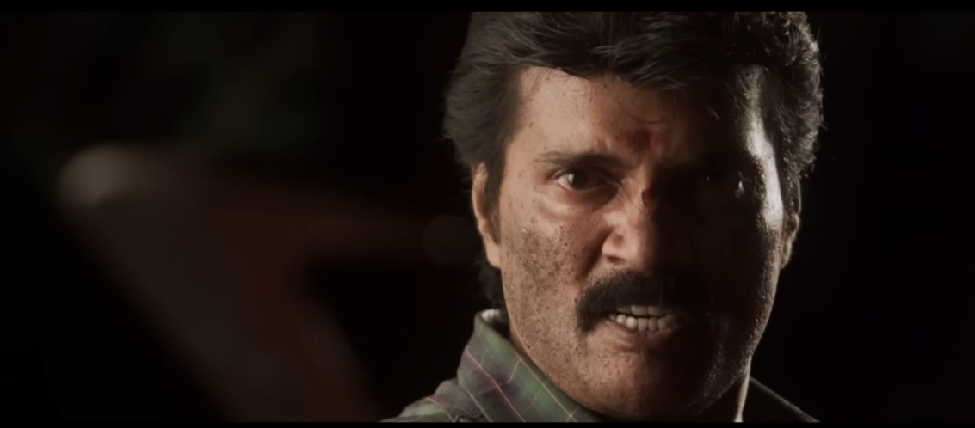
(சமத்துவம்…காதலிக்கும்போது சாதி தேவையில்லை…ரெஜிஸ்டர் ஆபீஸ் போகும்போது சாதி தேவையில்லை…ஆனா ஒரு பிரச்சனை வந்தா மட்டும் சாதிங்குற ஆயுதத்த கையில எடுக்குறீங்க... சாதிங்குறது ஆறி போன தழும்பு டா…ஏன் டா அதையே திரும்ப திரும்ப வெற்றிங்க…?)

The picture of character Kuzhandhai from the climax part
PICTURE CREDITS : Five Star Audio youtube channel

However, in reality, many youngsters are being killed by so called dominant caste people in the name of honour killing. There is a recent case regarding this.
“A 27-year-old Dalit software engineer was hacked to death in broad daylight on Sunday in what police and family members described as a case of caste-based honour killing. The victim, Kavin Selva Ganesh, was allegedly murdered by the brother of a woman he had been in a long-term relationship with. The accused, 21-year-old S Surjith, surrendered to police shortly after allegedly attacking Kavin near a private Siddha hospital in KTC Nagar, Tirunelveli, where the woman, Subashini, works as a consultant. Surjith is the son of two police officers — sub-inspectors Saravanan and Krishnakumari — both of whom have also been named as co-accused in the case for allegedly inciting the crime and threatening Kavin in the past.” (The Indian express, 29 July 2025)
Not only this but also there are so many honour killing cases across Tamilnadu, includes,
“Newly-weds Nandesh, a Dalit man and Swathi, a dominant caste Vanniyar woman, were brutally murdered; their bodies were found floating near the Shivanasamudra Falls in Karnataka’s Mandya district, over 150 km from Hosur.” (The News Minute, 28 November 2018)
“The homicide of a 21-year-old Dalit youth that was staged as a suicide by the members of a caste Hindu outfit who were infuriated by the mere sight of him conversing with his classmate — a woman belonging to an intermediate community, shook Tamil Nadu nearly eight years ago.” (The Hindu, 04 June 2023)
Honour killing is happening not only to dalits. It also happens when individuals loves within their community. A classic case for this is “Murugesan and Kannagi, of Pudukkoorapettai near Virudhachalam, were poisoned to death. The reason: Kannagi, of the Vanniyar community, married Murugesan, a Dalit of the same village” (The Hindu, 19 May 2025)
These are the cases that we can see, but there are also many cases that didn’t get media attention.

BEEF IS FOOD, NOT A CULTURE
In this film Kavundampalayam (2024) beef is directly portrayed as a food of dalits through the dialogue of the character of “Irumbusangili”.
The dialogue is,
“Sucking the juice out of everything was the past… Biting and chewing the bone is the present… Bite and chew it, guys… Bite…”
(உறிஞ்சி தின்னதெல்லாம் அந்த காலம்…எலும்ப கடிச்சு திங்கிறது இந்த காலம்… கடிச்சு தின்னுங்கடா… கடி…)
This type of portrayal enhances the false narrative that beef is the food of Dalits. Furthermore, a societal narrative exists that beef is the food for Dalit people, for which a case study exists.
“The alleged absence of beef during the initial stages of this year’s food festival in Chennai, held by the Tamil Nadu Urban Livelihoods Mission (TNULM), has sparked a row. City-based activists have said the beef dishes were introduced at the event only after the unavailability was flagged”.(The print, 24 December 2024)
I went to the Chennai food festival to enquire. Regarding this issue, the organizers of the Chennai Food Festival provided an explanation. They said, "That is to say, beef, like other meats, is being sold at the food festival. Beef is being sold at Stall Number 17, which was allotted for selling foods from the Karur district. No food was deliberately excluded.".However, the person running Stall Number 17 said, "We did not sell beef at this stall from the first day. This was because we had a doubt if we sold beef, would it be treated and sold like any average meat? Moreover, the political situation here also views it as an excluded food. Furthermore, we belong to a Muslim family, so we were afraid that if we took the lead on this, we might face some problem. However, we started selling beef on the second day. We never expected there to be so many beef lovers in Chennai. This is because only beef has been selling since the morning. A separate crowd comes just to eat it. Mutton, chicken, and other items are not selling and remain untouched. Therefore, as far as I am concerned, beef is just a food, not a culture."
In a place like Tamil Nadu, especially Chennai, where diverse people live, the exclusion of beef is unacceptable. This is because, in the current environment, everyone has started consuming beef. It is completely wrong to say that only people from a specific community should eat this food. "Food is food, it is not culture."
It is thus abundantly clear that even today, beef is still viewed as a culture and a food consumed by a specific caste. This unfortunate situation will only change when caste based problems and communal issues disappear from this society, and when left wing thoughts and progressive ideas emerge in the minds of the people.
The scene related to beef in the film Kavundampalayam (2024) seems to be encouraging such regressive ideas.

VCK’S LEADER THOL. THIRUMAVALAVAN IS THE VOICE OF THE VOICELESS
There is a character called “Irumbusangili” in the film Kavundampalayam (2024) which typically sets a false narrative about Viduthalai Chiruthaigal Katchi’s (VCK) leader Thol. Thirumavalavan.
Definitely, readers will ask the basis on which the researcher concluded that the Irumbusangili character was designed to set a fake narrative about Thirumavalavan.
Firstly, the party name of Irumbusangili indirectly portrays the VCK. The party name of Irumbusangili was “Ottrumai Chipoygal Katchi (OCK).”
Secondly, there is a dialogue for Irumbusangili. In that dialogue, Thirumavalavan’s popular song “Kaiya katti vaaya pothi” (Thirumavalavan news) is directly used.
The dialogue is,
“Sucking the juice out of everything was the past… Biting and chewing the bone is the present… Bite and chew it, guys… Bite…Only those who act well become Superstars, man. People who acted well have even captured nations. Can’t you capture just one girl? You must act… You must act so well that the whole world says you are everything. You must act so well that she forgets her own parents. You must act so well that she says she’ll die without you.The world’s heart is like a flower, man… This doesn’t need money… Just show affection, that’s enough… Looks aren’t important for this… Just being a man is enough… We have the stuff (substance) and the swagger. Keep your body strong.Which father will agree to his child’s love? If you want to make him agree, go immediately and finish the matter.Marry the one with money. If anyone questions you, cut them down, even if it’s God. Women are their only honor, man.Let it win! Let the love revolution win!”
(உறிஞ்சி தின்னதெல்லாம் அந்த காலம்… எலும்பை கடிச்சு திங்கிறது இந்த காலம்… கடிச்சு தின்னுங்கடா… கடி… நல்லா நடிச்சா தான்டா சூப்பர் ஸ்டாரு. நல்லா நடிச்சவங்க தான் நாட்டையே புடிச்சிருக்காங்க உங்களால் ஒரு பொண்ண புடிக்க முடியாதா… நடிக்கணும்… இந்த உலகமே நீங்க தான் சொல்ற அளவுக்கு நடிக்கணும். அவங்க அப்பா அம்மாவ மறக்குற அளவுக்கு நடிக்கணும். நீ இல்லன்னா செத்துருவேன்னு சொல்ற அளவுக்கு நடிக்கணும். உலக மனசு பூ மாதிரி டா… இதுக்கு பணம் தேவை இல்லை… பாசத்தை காட்டினா போதும்… இதுக்கு அழகு முக்கியமில்ல… ஆம்பளையா இருந்தா போதும்… நம்மகிட்ட சரக்கு இருக்கு மிடுக்கு இருக்கு. உடம்ப வலுவா வச்சுக்கணும். எந்தப்பனாவது தன் புள்ள காதலிக்கிற ஒத்துப்பானா… அவன ஒத்துக்க வைக்கணும்னா போன உடனே மாற்றம் முடிச்சிரு. காசு உள்ளவள கட்டு. ஏன்னு கேட்டா கடவுளா இருந்தாலும் வெட்டு. அவங்களுக்கு மானமே பொண்ணுங்க தான்டா…வெல்லட்டும் வெல்லட்டும் காதல் புரட்சி வெல்லட்டும்…)
Through the activities of the character Irumbusangili, Director Ranjith directly tries to set fake narratives that Thirumavalavan is encouraging Dalit youngsters to pretend to be in love with high caste people for money and to spil the pride of so called higher caste people.
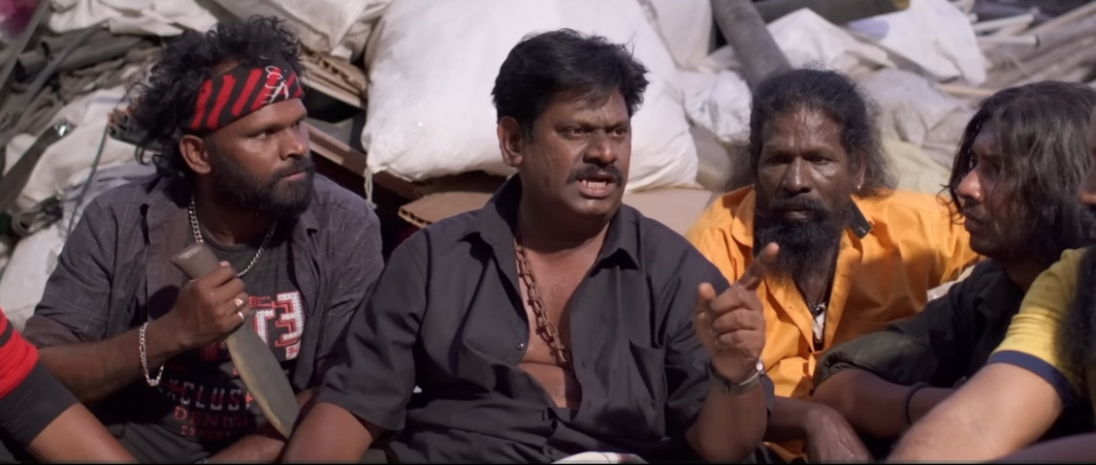
The picture of the character Irumbusangili from the movie
PICTURE CREDITS : Five Star Audio youtube channel

A person from the Dalit community said regarding this,"It is absolutely wrong to claim through films that Dalit youth are engaging in Pretended love (நாடக காதல்). If loving someone from a different caste is considered Pretended love, then Director Ranjith himself is in an inter caste marriage; in that sense, is his love also pretended love? Furthermore, if Director Ranjith genuinely cared about the women of his own caste, he would not have portrayed them negatively (in a sexual way).The biggest reason and the main motivation for such films coming to the film industry is the Anti-Thiruma stand. That is, the thought is that if they oppose Thirumavalavan, audiences will come to the theaters to watch the film, and they can make a profit from it.Misrepresenting Thirumavalavan to this extent is unacceptable. This is because Thirumavalavan is not someone who discriminates based on caste. If you closely observe the Viduthalai Chiruthaigal Katchi (VCK), you will see that Dalits are not the only members or executives, people from all castes are present.In the current scenario, directors like Pa. Ranjith, Vetri Maaran, and Mari Selvaraj are bringing the pain and voice of the Dalit people to the masses through their films. Examples include films like Pariyerum Perumal, Vaazhai, and Thandakaaranyam. Moreover, even non-Dalit directors are now discussing Dalit politics in their movies. Even in commercial films like Lubber Bandhu, discussing Dalit politics has become mandatory.Films like Kavundampalayam can only be seen as movies that emerge because some people cannot tolerate the voices of those who were suppressed for so long now resounding in theaters." (Jaya Krishna)

Thirumavalavan has been a leader who has consistently raised his voice in support of Eelam Tamils, people from various social groups, and any oppressed caste since his youth.
He was deeply drawn to the cause of the Eelam Tamils and the Liberation Tigers of Tamil Eelam (LTTE), even started a handwritten magazine called “Viduthalai Puli” (Liberation Tiger) with his friends.
Notably, during the 2006 Assembly Elections, he urged the DMK leader M. Karunanidhi to ensure elections were held in the villages of Pappapatti and Keeripatti, which were historically not holding elections due to caste based issues. Consequently, elections were conducted in those two villages during the DMK’s term.
Furthermore, on October 2, 2024, a liquor prohibition conference was held in Vikravandi under his leadership on behalf of the Viduthalai Chiruthaigal Katchi (VCK) party. Despite various criticisms leveled against the conference from different angles, Thirumavalavan successfully concluded the liquor prohibition conference. Even when facing criticism about “Paraiyar and Panchayat politics,” he gave responsibilities within the party not just to Dalits, but also to others, including women and minorities.
We can list so many good things Thirumavalavan did for people.
In this way, Thirumavalavan continues his social service by taking the field as the voice for the voiceless and oppressed people of any community.
As a person belongs to Dalit community I can’t accept Portraying Thol. Thirumavalavan in a wrong way.

REALITY OF DALITS LIFE
There is a dialogue in this movie by the character Kuzhandhai (acted by Ranjith) at the climax where he tells that dialogue towards Irumbusangili.
The dialogue is,
“Earning money and doing Katta Panchayat in the name of love.when questioned, they crush, squash, oppress, and paralyze… Ptoo (spitting sound)… You filthy dog!”
(காதல் என்ற பெயரில் காசு சம்பாதிக்கிறது கட்டப்பஞ்சாயத்து பண்றது ஏன்னு கேட்டா நசுக்குறாங்க, பிசுக்குறாங்க, ஒடுக்குறாங்க, முடக்குறாங்க…தூ… எச்சக்கல நாயே…)
But, just think till today how many cases are there how dalits are marginalized in the name of caste. We have many case studies regarding this.
“In December 2022, five children from Dalit families in Vengaivayal fell ill after unknowingly drinking water from the same overhead drinking tank. Further probes revealed that the water had been contaminated with human excreta. A case was booked under the Prevention of SC/ST Atrocities Act.In February 2023, a fact-finding report by the Dalit Intellectual Collective said that previous enmity existed between the former Panchayat head Chidambaram, from the Kallar (OBC) caste, and Muthiah and Padma. Even though Padma had won the local body polls in 2019, Muthiah allegedly held a grudge against the Dalit residents of Vengaivayal, believing they had voted for Chidambaram, the report said.Further, Muthiah reportedly held a grudge against tank operator Shanmugam, who is from the Keezh Valaiyar (a Mutharaiyar sub-caste) community, for bringing Panchayat attention to issues faced by Vengaivayal Dalits. The report alleged that Muthiah fired Shanmugam in retaliation but was infuriated when Shanmugam blocked the move by obtaining a work order from the Block Development Officer (BDO)”. (The Hindu, 24 June 2025)

“Chinnadurai’s schoolmates, hailing from an MBC community, had often harassed him and also asked him to buy them cigarettes. As he complained about this to the school headmaster, the three students had entered his house and hacked him multiple times. His 14-year-old sister was also injured when she attempted to intervene and save him.With severe injuries, the duo was admitted to the Tirunelveli Medical College Hospital (TvMCH) where Chinnadurai was treated for nearly four months. Doctors from Chennai were brought in to perform surgery on his hand. As Chinnadurai could not continue his studies in his Valliyur-based government-aided school, Collector K P Karthikeyan got him into a Tirunelveli-based school after his discharge. The collector also admitted Chinnadurai’s sister to another school in Tirunelveli and arranged a house for his family in the city”.(The New Indian Express, 07 May 2024)
Not only these, there many news regarding the caste based violence towards dalits.

Even in many Dalit residential areas, there are no basic amenities. They are being oppressed for their caste. Regarding this, a politician shared his experience with the Dalit livelihood “Nearly 75 years have passed since we attained independence, yet even today, Dalit people in the Western region are suffering to the extent that they lack even basic amenities. Specifically, in Udumalaipettai, Tiruppur district, which is part of the Western region, the Dalits living there do not have proper cremation ground facilities. The situation there is that corpses have to be buried on the footpaths. They remain a people who are lagging behind educationally and economically. Furthermore, they lack proper road facilities and electricity facilities, and they are subject to dominance and oppression. Even today, the Dalits living there have not gained political awareness and have not united as a political force.” (M. Thiruvalavan, Politician)
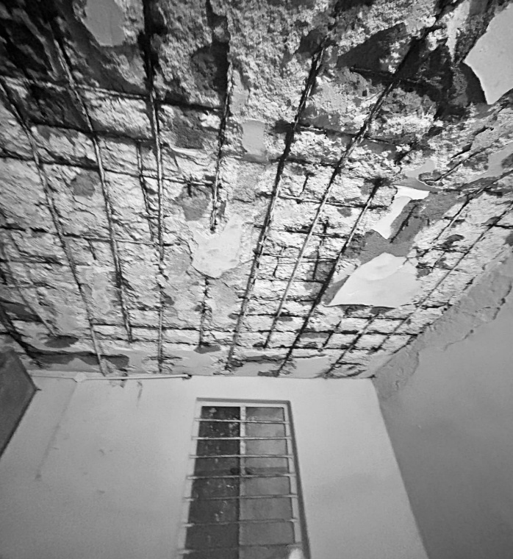
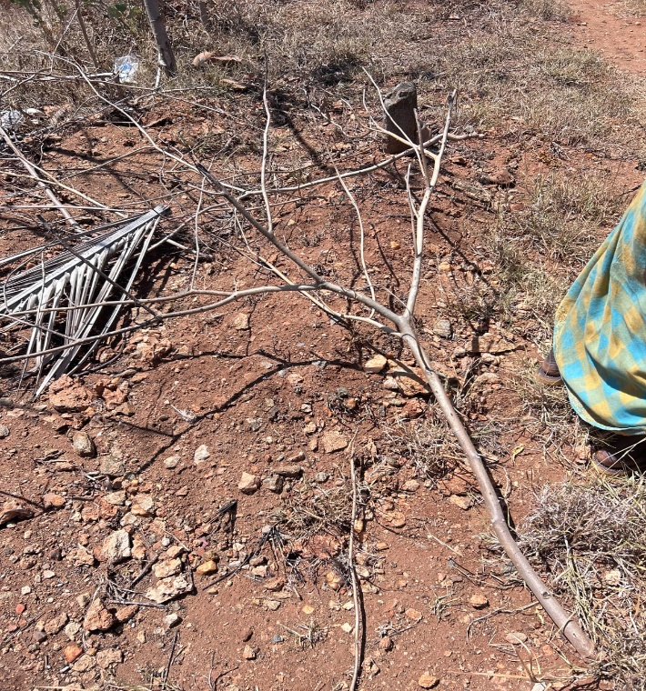
The road where people bury corpse and the roof of the house
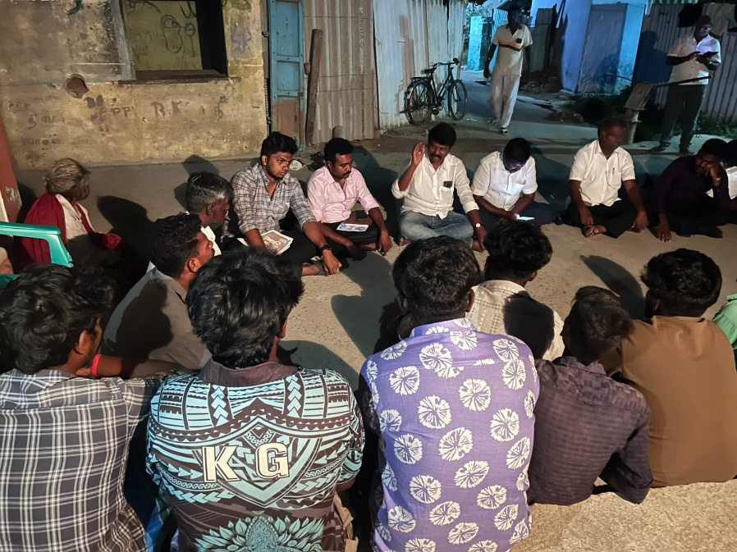
The picture of the discussion by Tamil Puligal Katchi
(Thiruvalavan took part in this discussion) PICTURE CREDITS : M. Thiruvalavan

The suffering of Dalit people and the violence they face isn’t limited to just the Western region similar incidents are constantly occurring in the Southern and Northern districts as well. Therefore, it is deeply wrong to write dialogue in a film or express the idea that Dalit people are not oppressed along caste lines. Even today, practices like the Two Tumbler system (இரட்டைக் குவளை), denying people temple entry based on caste, and untouchability still exist in many places. As a person belonging to the Dalit community, I absolutely can’t accept this.

CINEMA IS AN ARTFORM, NOT A TOOL FOR PREACH THE CASTE PRIDE
In our society, there are various problems related to caste and religion. As already mentioned, Directors like Pa. Ranjith, Mari Selvaraj, and Vetri Maaran convey these issues to the people through their works. However, on one side, directors like Ranjith seem to be instilling caste pride among the people.

In this regard, a film critic said, “Art transcends caste, religion, and language. Art has no boundaries. And the art of cinema is a very important form of art. Films are for entertainment. However, when needed, they can convey good messages essential for society. Even during India’s freedom struggle, poets like Bharathiyar wrote many inspiring songs about independence. Moreover, theaters are places without discrimination. Theaters can even be called a place where untouchability was abolished. ‘Just as the lights are dimmed in the theaters, so too are the caste based discriminations extinguished in that space’. It is deeply concerning that films promoting caste pride are being screened in such theaters. On the YouTube platform ‘Parithabangal,’ ‘Gopi’ and ‘Sudhakar’ convey many good messages for social change through comedy. Similarly, current directors like Mari Selvaraj, Pa. Ranjith, and Vetri Maaran portray the pain and problems of the oppressed people through films. In a nutshell, ‘Films can talk about the pain, struggles and experience due to caste but they should not talk about caste pride.’
After the BJP came to power at the center, we have been seeing an increase in Islamophobic films circulating recently. For example, the BJP heavily criticized the recently released film ‘The Kerala Story’. Even the court condemned the CBFC for its various actions concerning this film. Incidents like this help us understand that the CBFC, which has the authority to remove objectionable scenes and dialogues in horror films, is also supporting the ruling party. It is very concerning that the film industry is moving towards a dominant mindset. The result of this will be that healthy and progressive creations will not come to the cinema”. (Subair)

Therefore, it is clear that instilling and speaking of caste pride in films is a hindrance to social peace.

APPLICATION OF REPRESENTATION THEORY
REPRESENTATION –
As Hall S. said, through movies, filmmakers don't reflect reality instead, they are constructing narratives with an intentional view. This is proven by the movie Kavundampalayam.
Director Ranjith, who is from Coimbatore, is alleged to reflect his anti-oppressed dominance through his film by stating that Dalits are not being marginalized. He also suggests that a Dalit youngster engages in pretended love. Furthermore, he intentionally targets Viduthalai Chiruthaigal Katchi's (VCK) leader Thol. Thirumavalavan, portraying him as doing Katta panchayat (an unofficial or kangaroo court). Additionally, he establishes a false narrative that beef is solely a Dalit cultural practice or food.It clearly reflects the relationship between media power and dominance ideology.
This type of false narrative clearly enhances caste discourse, caste violence, and caste hierarchies among people.

ENCODING AND DECODING –
Encoding
Dominant Ideology - The preservation of traditional caste boundaries and the defense of parental control over inter caste or fake dramatic marriages, particularly for girls from dominant castes.
The Encoded Message
Narrative Focus - The plot centers on a Man from the Kongu Vellalar community who works to win back his girl after she elopes with a lover from a Scheduled Caste. The film frames the elopement as a pretended love.
Justification of Caste Vengeance - Director Ranjith himself stated the film is a tribute to parents of girls who sacrifice their lives to protect their daughters and against boys hailing from low caste background marrying girls from high.
Explicit Defense of Violence - In post release interviews, “Actor-director Ranjith, who has acted in Tamil and Malayalam films since the early 90s, made a shocking statement defending honour killing. He spoke to the press post a screening of his recent directorial Kavundampalayam in Salem, Tamil Nadu on August 9 and said that ‘caste-based honour killing isn’t violence’”. (Hindustan Times) (10 August 2024).This statement reinforces the film's underlying ideological position that parent’s anger and actions to control their children's marriages are justified and rooted in care.

Decoding
1.Dominant Reading – The audience fully accepts the film’s message as encoded, aligning with the dominant caste ideology.
- Decoding - They would view the protagonist’s actions to win back his girl and the condemnation of the inter caste relationship as morally correct and an affirmation of their own cultural and caste values. They would agree with the filmmaker that inter caste elopements and that parental authority and the maintenance of caste purity are paramount social duties. They would interpret the controversy and the director’s remarks as a necessary defense of traditional family values against modern, influences.
2.Negotiated reading – The audience acknowledges the film’s primary conflict and the emotional distress of the parents, but they reject the extreme, politically regressive conclusions.
- Decoding - They might sympathize with the theme of parental anguish, understanding the cultural pressure on parents to control their children’s lives. However, they would reject the director’s justification of caste based violence.They may hold a general belief in endogamy but believe the film’s narrative is socially harmful.
3.Oppositional reading – The audience completely rejects the preferred meaning, decoding the film in a way that is radically contrary to the dominant hegemonic ideology.
- Decoding – They would interpret the film not as a tribute to parents, but as regressive, casteist propaganda that actively promotes caste based vengeance and misogyny. The protagonist is seen not as a hero, but as a perpetuator of violence and an agent of a dominant caste structure.This type of reading is likely taken by social activists, human rights groups, critics, and members of the Scheduled Castes who recognize and oppose the film’s narrative as a direct challenge to social reform, individual choice, and anti caste efforts. They see the film’s message about “parental care” as a thinly veiled justification for a violent, centuries old oppression.Honoor killing is murder, not care.

REFERENCES
Aneesa Pa, The Print (24 December 2024). ‘Discrimination’ against beef at Chennai food fest sparks row, slammed as ‘casteist mentality’. https://theprint-in.cdn.ampproject.org/v/s/theprint.in/india/discrimination-against-beef-at-chennai-food-fest-sparks-row-slammed-as-casteist-mentality/2417169/?amp=&amp_gsa=1&amp_js_v=a9&usqp=mq331AQIUAKwASCAAgM%3’#amp_tf=From&ampshare=https%3A%2F%2Ftheprint.in%2Findia%2Fdiscrimination-against-beef-at-chennai-food-fest-sparks-row-slammed-as-casteist-mentality%2F2417169%2F
Anna Isaac, The News Minute (28 November 2018). How caste hatred killed love: The murders of Hosur's Nandesh and Swathi. https://www.thenewsminute.com/tamil-nadu/how-caste-hatred-killed-love-murders-hosurs-nandesh-and-swathi-91915
Arun Janardhanan, Indian Express (29 July 2025). Tamil Nadu Dalit techie hacked to death in ‘honour killing’, police couple’s son arrested. https://indianexpress.com/article/cities/chennai/tamil-nadu-dalit-techie-hacked-to-death-in-honour-killing-10155361/
.Devaki V, ResearchGate (March 2019).Representation of cast€ in Tamil cinema : pride and prejudice. https://www.researchgate.net/publication/332246742_Representation_of_Caste_in_Tamil_Cinema_Pride_and_Prejudice
Five Star Audio (1 yaer ago). Kavundampalayam official trailer. https://youtu.be/Cj8CH4GuavA?si=Jz1q2N75WAY25geO
Hindustan Times, Neeshita Nyayapati (10 August 2024). Tamil actor Ranjith justifies caste-based honour killing: ‘It is not violence, just parents’ care for their children’. https://www.hindustantimes.com/entertainment/tamil-cinema/tamil-actor-ranjith-justifies-caste-based-honour-killing-it-is-not-violence-just-parents-care-for-their-children-101723276142290.html
Lalitha Ranjani, The Hindu (04 June 2023). Explained | What is the Gokulraj murder case all about?. https://www.thehindu.com/news/national/tamil-nadu/explained-what-is-the-dalit-youth-gokulraj-murder-case-in-tn-namakkal-all-about/article66922944.ece
Ranjith, Aaha OTT platform (2024). Kavundampalayam. https://www.aha.video/
R. Sivaraman, The Hindu (19 May 2025). Kannagi-Murugesan ‘honour’ killing: a crime that revealed the ugly reality of caste. https://www.thehindu.com/news/national/tamil-nadu/a-crime-that-revealed-the-ugly-reality-of-caste/article69590245.ece
Stuart Hall, Study Rocket. Representation theory (Hall). https://studyrocket.co.uk/revision/a-level-media-studies-eduqas/advertising/representation-theory-hall
The New Indian Express (07 May 2024). Nanguneri caste violence victim scores 78 per cent marks. https://www.newindianexpress.com/states/tamil-nadu/2024/May/07/nanguneri-caste-violence-victim-scores-78-per-cent-marks
The News Minute (24 January 2025). Vengaivayal water contamination: 3 Dalit men accused of crime motivated by vendetta. https://www.thenewsminute.com/tamil-nadu/vengaivayal-water-contamination-3-dalit-men-accused-of-crime-motivated-by-vendetta

